

**USMAN INSTITUTE OF TECHNOLOGY**

**DEPARTMENT OF ELECTRICAL ENGINEERING**

**COMPUTER SYSTEMS**

**COURSE NAME: COMPUTER COMMUNICATION NETWORKs**

**COURSE CODE**: **EL 303**

**Project Name: UNIVERSITY SYSTEM**

**Submitted To: ENGR. MARUIM ATTA**

**Dated:**15th of August’ 2020

**MEMBERS:**

**Iqra Fasih 17b-009-ce**

**Syed Hassan Asghar 17b-033-ce**

**Tuba Siddiqui 17b-042-ce**

**Syed Muhammad Murtaza Ali Zaidi 17b-044-ce**

Table of Contents

INTRODUCTION: 4

METHODOLOGY: 4

CODING: 5

SECOND FLOOR ROUTER CLI CODING: 5

GROUND FLOOR ROUTER CLI CODING: 5

ACL1: PERMITTING LIBRARIAN PC AND DENYING FINANCE DEPARTMENT TO ACCESS 2ND FLOOR PCS: 6

ACL2: PERMITTING ONLY MAIN PC OF CL2 TO ACCESS FACULTY PCS: 6

DENYING ACCESS FROM ALL DEPARTMENTS TO FINANCE DEPARTMENT: 7

OLD BUILDING ROUTER CLI CODING: 7

OUTSIDE ROUTER CLI CODING: 8

CONNECTING S3/0 OF SECOND FLOOR WITH S2/0 OF ROUTER A: 8

SECOND FLOOR CLI CODING: 8

ROUTER A CLI CODING: 9

S3/0 GROUND FLOOR WITH S3/0 OF ROUTER A: 9

GROUND FLOOR ROUTER CODING: 9

ROUTER A CLI CODING: 9

S3/0 OLD BUILDING WITH S2/0 OF ROUTER B: 9

OLD BUILDING CLI CODING: 9

S3/0 OUTSIDE WITH S3/0 OF ROUTER B 10

ROUTER B CLI CODING FOR BOTHE OLD BUILDING AND OUTSIDE: 10

ROUTER MAIN: 10

ROUTER A AND ROUTER MAIN 11

ROUTER MAIN AND ROUTER B 11

ACL FOR ROUTER OLD BUILDING 11

ACL FOR ROUTER OUTSIDE 12

IPS 13

FACULTY: 13

COMPUTER LAB: 13

OLD FAULTY: 14

NETWORKING LAB: 14

LIBRARY: 14

FINANCE DEPARTMENT: 15

ACADEMICS: 15

ADMINISTRATION: 15

DIAGRAM OF CISCO CIRCUIT 16

ADVANTAGES 16

FUTURE WORK 16

# INTRODUCTION:

The Computer network allowed out of the need to use personal computers for sharing information within an organization in the form of messages, sharing files, resources. Whether the organization is located in a small area like as in one building or spread over a large area, the need for networking the computers cannot be over emphasized. A university area network is an essential part of university system. A university network has several uses such as teaching, learning, result publishing, resource sharing, file sharing, communication, etc. university network should be designed on the basis of star topology having one switch or hub which connects all the hosts on the network creating the LAN of network it like a client server topology all the clients are connected to one server due to which in university can print the document from the printer from any pc. It is low cost network. And has a less effect of failure on other hosts as one pc have some failure as its connected by its own cable into hub it will not affect the other pcs. It is easily expandable and high data speeds. The basic purpose is to design university system to give the idea how we can use technology to make network and structure of the university more effective and less time consuming. In this project we create university system by using cisco packet tracer for Usman institute of technology in which we provide basic and effective idea for the university network or any small education sector

# METHODOLOGY:

This network consists of eight rooms taken from UIT.

* Finance
* Academics
* Administration
* Computer lab
* Networking lab
* Faculty
* Old faculty
* Library

Starting from finance, since it is a secured place, no other pc of any room can access it. Every other PC is denied. This lies on ground floor and so is connected with a ground floor router. Similarly, library is situated on ground floor and its main PC that is used by the librarian has access to all the main PCs of each room except finance, academics and administration.

On second floor, there is a computer lab and a faculty. Main PC of computer lab can accessed all PCs in second floor faculty and old building’s old faculty. Whereas faculty PCs can only access the main PC of computer lab main PC of networking lab.

On outside lies academics and administration. These both rooms can only access each other’s main PCs and has no link with any PC of any room.

Lastly, old building has networking lab and old faculty. Old faculty can access main PC of networking lab as well as computer lab. It has no connection with second floor faculty. Networking lab’s main PC can access all PCs of old faculty and second floor faculty, as well as library’s main PC and computer lab’s main PC.

# CODING:

## SECOND FLOOR ROUTER CLI CODING:

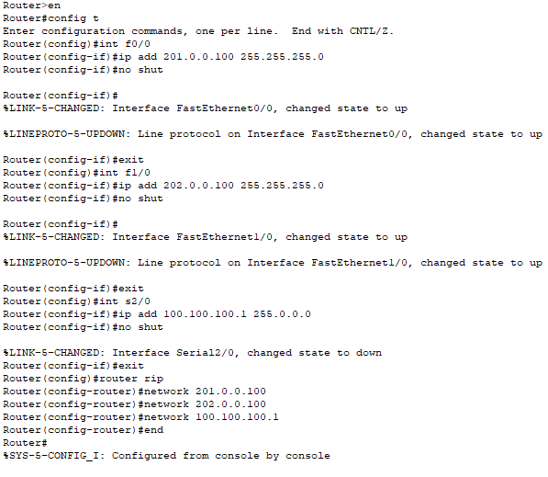



## GROUND FLOOR ROUTER CLI CODING:

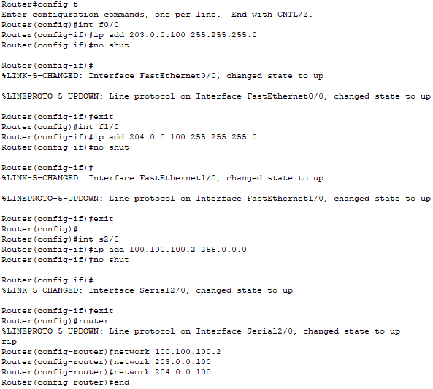





## ACL1: PERMITTING LIBRARIAN PC AND DENYING FINANCE DEPARTMENT TO ACCESS 2ND FLOOR PCS:

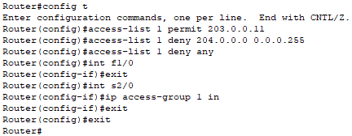

## ACL2: PERMITTING ONLY MAIN PC OF CL2 TO ACCESS FACULTY PCS:

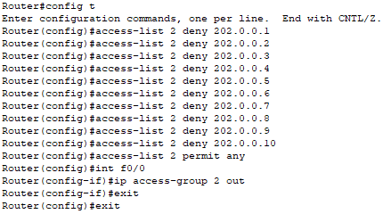

## DENYING ACCESS FROM ALL DEPARTMENTS TO FINANCE DEPARTMENT:

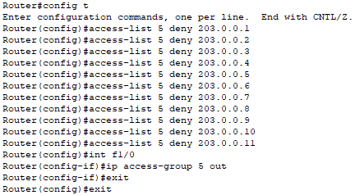

## OLD BUILDING ROUTER CLI CODING:

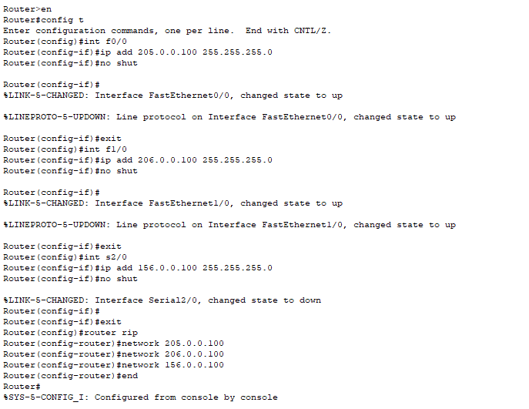



## OUTSIDE ROUTER CLI CODING:

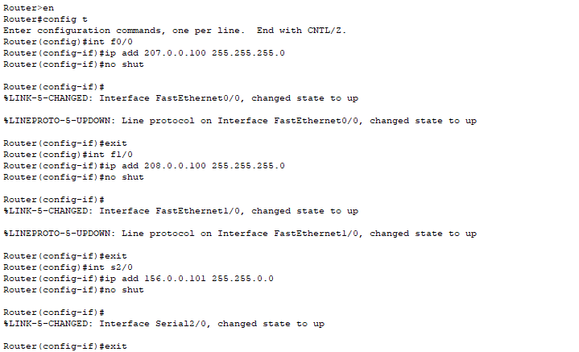

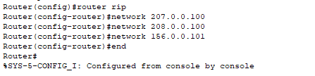

## CONNECTING S3/0 OF SECOND FLOOR WITH S2/0 OF ROUTER A:

### SECOND FLOOR CLI CODING:

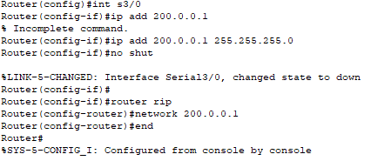

### ROUTER A CLI CODING:

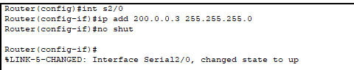



## S3/0 GROUND FLOOR WITH S3/0 OF ROUTER A:

### GROUND FLOOR ROUTER CODING:

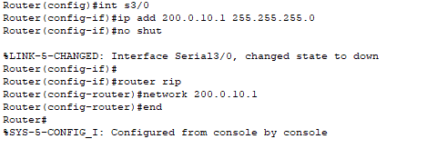

### ROUTER A CLI CODING:

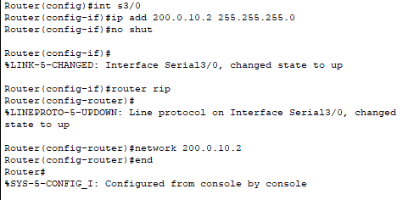



## S3/0 OLD BUILDING WITH S2/0 OF ROUTER B:

### OLD BUILDING CLI CODING:

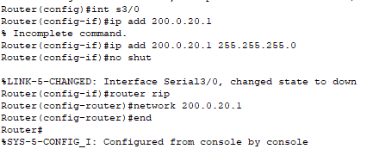



## S3/0 OUTSIDE WITH S3/0 OF ROUTER B

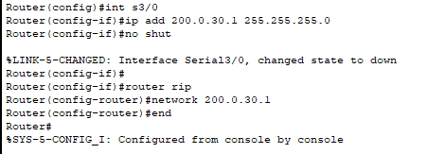

### ROUTER B CLI CODING FOR BOTHE OLD BUILDING AND OUTSIDE:

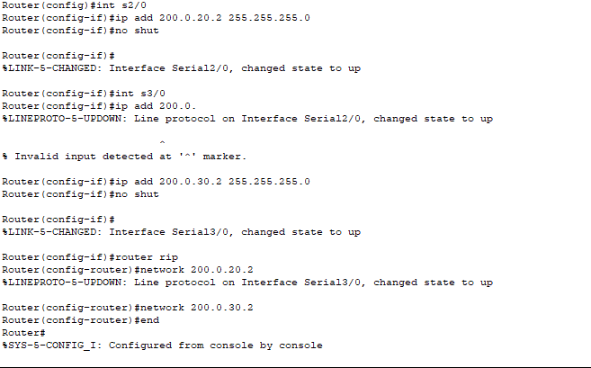



## ROUTER MAIN:

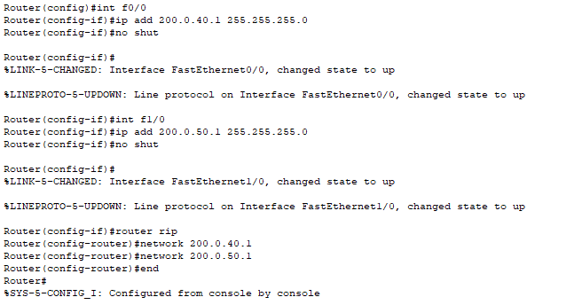



## ROUTER A AND ROUTER MAIN

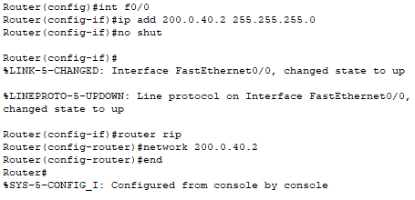

## ROUTER MAIN AND ROUTER B

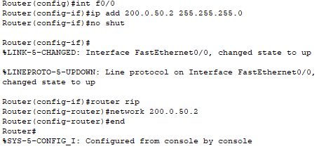

## ACL FOR ROUTER OLD BUILDING

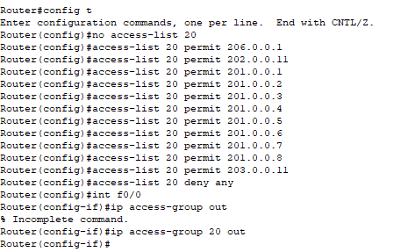



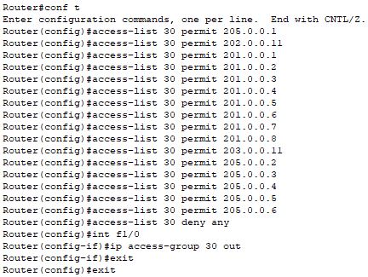

## ACL FOR ROUTER OUTSIDE

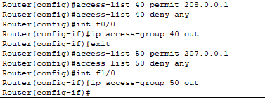

**Only academics and administration can access each other.**

# IPS

## FACULTY:

|  |  |
| --- | --- |
| **PC** | **IP address** |
| **PC-PT** | 201.0.0.1 |
| **PC-PT** | 201.0.0.2 |
| **PC-PT** | 201.0.0.3 |
| **PC-PT** | 201.0.0.4 |
| **PC-PT** | 201.0.0.5 |
| **PC-PT** | 201.0.0.6 |
| **PC-PT** | 201.0.0.7 |
| **PC-PT** | 201.0.0.8 |
| **Printer-PT** | 201.0.0.9 |
| **Printer-PT** | 201.0.0.10 |
| **Printer-PT** | 201.0.0.11 |
| **Printer-PT** | 201.0.0.12 |
| **Printer-PT** | 201.0.0.13 |
| **Printer-PT** | 201.0.0.14 |
| **Printer-PT** | 201.0.0.15 |
| **Printer-PT** | 201.0.0.16 |

## COMPUTER LAB:

|  |  |
| --- | --- |
| **PC** | **IP address** |
| **PC-PT** | 202.0.0.1 |
| **PC-PT** | 202.0.0.2 |
| **PC-PT** | 202.0.0.3 |
| **PC-PT** | 202.0.0.4 |
| **PC-PT** | 202.0.0.5 |
| **PC-PT** | 202.0.0.6 |
| **PC-PT** | 202.0.0.7 |
| **PC-PT** | 202.0.0.8 |
| **PC-PT** | 202.0.0.9 |
| **PC-PT** | 202.0.0.10 |
| **PC-PT(main)** | 202.0.0.11 |
| CL-1 PRINTER | 202.0.0.12 |

## OLD FAULTY:

|  |  |
| --- | --- |
| **PC** | **IP address** |
| **PC-PT** | 205.0.0.1(Main) |
| **PC-PT** | 205.0.0.2 |
| **PC-PT** | 205.0.0.3 |
| **PC-PT** | 205.0.0.4 |
| **PC-PT** | 205.0.0.5 |
| **PC-PT** | 205.0.0.6 |
| Old Faculty Printer | 205.0.0.50 |

## NETWORKING LAB:

|  |  |
| --- | --- |
| **PC** | **IP ADDRESS** |
| **PC-PT** | 206.0.0.1(Main) |
| **PC-PT** | 206.0.0.2 |
| **PC-PT** | 206.0.0.3 |
| **PC-PT** | 206.0.0.4 |
| **PC-PT** | 206.0.0.5 |
| **PC-PT** | 206.0.0.6 |
| **PC-PT** | 206.0.0.7 |
| **PC-PT** | 206.0.0.8 |
| **PC-PT** | 206.0.0.9 |
| CL-1 Printer | 206.0.0.50 |

## LIBRARY:

|  |  |
| --- | --- |
| **PC** | **Ip address** |
| **PC-PT** | 203.0.0.1 |
| **PC-PT** | 203.0.0.2 |
| **PC-PT** | 203.0.0.3 |
| **PC-PT** | 203.0.0.4 |
| **PC-PT** | 203.0.0.5 |
| **PC-PT** | 203.0.0.6 |
| **PC-PT** | 203.0.0.7 |
| **PC-PT** | 203.0.0.8 |
| **PC-PT** | 203.0.0.9 |
| **PC-PT** | 203.0.0.10 |
| **PC-PT** | 203.0.0.11(main) |
| **PC-PT** | 203.0.0.12 |

## FINANCE DEPARTMENT:

|  |  |
| --- | --- |
| **PC** | **Ip address** |
| **PC-PT** | 204.0.0.1 |
| **PC-PT** | 204.0.0.3 |
| **PC-PT** | 204.0.0.5 |
| **PC-PT** | 204.0.0.7 |
| **Printer-PT** | 204.0.0.2 |
| **Printer-PT** | 204.0.0.4 |
| **Printer-PT** | 204.0.0.6 |
| **Printer-PT** | 204.0.0.8 |

## ACADEMICS:

|  |  |
| --- | --- |
| **PC** | **Ip address** |
| **PC-PT** | 207.0.0.1(Main) |
| **PC-PT** | 207.0.0.2 |
| **PC-PT** | 207.0.0.3 |
| **PC-PT** | 207.0.0.4 |
| Academic Printer | 207.0.0.50 |

## ADMINISTRATION:

|  |  |
| --- | --- |
| **PC** | **Ip address** |
| **PC-PT** | 208.0.0.1(Main) |
| **PC-PT** | 208.0.0.2 |
| **PC-PT** | 208.0.0.3 |
| Administration Printer | 208.0.0.50 |

# DIAGRAM OF CISCO CIRCUIT

# ADVANTAGES

The main advantage of making university system is what network of university would eventually look like after it is implemented. Management of the portal according to the university requirement can be possible, management can look after all activities of faculty members and students during university premises, provides powerful communication, reduce time and cost. The university system provides all basic function which helps management to mange the network of university

# FUTURE WORK

The configuration and specifications are for the prototype model and can additionally be created and extra usefulness can be added to increase support and coverage. You implement this system other branches and other educational institute.